Article VIII: Supplemental Regulations

Section 8.1 Purpose

This Article provides additional and general provisions intended to enhance the community by ensuring land use compatibility, screening of unsightly uses, ensuring adequate provision of open space, and the protection of trees within the Town. Additionally, this Article provides parking and off-street parking and loading regulations.

Section 8.2 Applicability

The provisions of this Article apply to uses and structures in all districts unless specified otherwise in this Article.

Section 8.3 Buffer Areas

8.3.1 Definition
A buffer area is a unit of yard, together with plantings, fences, walls and other screening devices required thereon. Buffer areas can be natural vegetation or of manmade materials.

8.3.2 Purpose
The purpose of a buffer area is to ameliorate any potential adverse impact between adjacent land uses and streets, and promote land use compatibility.

8.3.3 Location
Buffer areas shall be located on the outer perimeter of a lot or parcel, extending to the lot or parcel boundary line. For purposes of complying with this Section, they shall not be located on any portion of an existing street or right-of-way; however, they may occupy part or all of any required front, side or rear yard setback. Where specified by this Section, buffer areas and/or buffer area structures shall be developed as an integral part of the proposed use.

8.3.4 Buffer Area Requirements
Buffer areas along the perimeter of lots, but not in a street right-of-way, which areas may be used for passive recreation only, shall be maintained by property owners as follows:
Table 8-1, Land Use and Buffer Sizes
TYPE | LAND USE | WHERE  REQUIRED | BUFFER SIZE AND  PLANTS REQUIRED
A | Multi-family complex, manufactured home park, non-residential use not adjacent to residential district, and all surface parking lots | Along street rights-of-way, except drive-ways & visibility angles. | Minimum buffer width: Five (5) feet.  Plants required per 100 feet of street frontage: Twelve (12) ornamental shrubs, Two (2) ever-green understory trees, and grass or other ground cover. Shrubs may be clustered.
B | Multi-family complex, manufactured home park, commercial or institutional use adjacent to single-family residential use not separated by street or alley. | Along adjacent residential property lines. | Minimum buffer width: Ten (10) feet.  Plants required per 100 linear feet: Two (2) deciduous canopy trees 40 to 60 feet on center, and eight (8) evergreen plants ten (10) feet on center.
C | Industrial, warehouse, outdoor sales or storage use adjacent to residential district not separated by street at least 18 feet wide. | Along adjacent residential district lines. | Minimum buffer width: fifteen (15) feet.  Plants required per 100 linear feet: Two (2) deciduous canopy trees 40 to 60 feet on center, and 17 evergreen plants or understory trees in double staggered rows ten (10) feet on center.
Plant Standards: | Minimum installation height: Evergreen understory trees - Six (6) feet; deciduous canopy trees - Eight (8) feet; ornamental shrubs- One (1) foot; standard shrubs- Two (2) feet.  Minimum mature size: Evergreens – Ten (10) feet; deciduous trees - 25 feet.
Substitutions: | Existing plants: Existing plants meeting minimum standards may be retained to meet buffer requirements.  Evergreens: Evergreen plants may be substituted for deciduous plants.  Fence or wall: Where existing lot use, size, shape, configuration, topography or unusual circumstances prevent reasonable compliance with buffer landscaping requirements, the Zoning Administrator may approve substitution of an opaque fence or wall at least six (6) feet in height, but not exceeding ten (10) feet in height, for a Type B or Type C buffer. Fences and walls shall be neat in appearance and have a finished surface facing adjacent property.

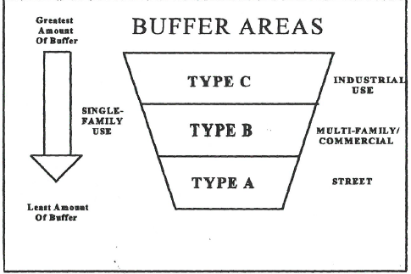
Figure 8-1, Buffer Areas – All Types

8.3.5 Design Standards
Three (3) types of buffer areas are required by this Ordinance, Type A, Type B, and Type C. Descriptions of each follows:

Type “A” Buffer Area.
Consists of low density landscaping and minimal acceptable separation between uses. The buffer area shall be not less than five (5) feet in width. Per 100 lineal feet of frontage, the buffer area shall consist of a combination of not less than 12 ornamental shrubs, two (2) understory trees and landscaped grass areas, or other appropriate ground cover. The shrubs may be clustered to ensure their survival.
Figure 8-2 shows an example of Type “A” Buffer Areas.

Figure 8-2, Type “A” Buffer Areas
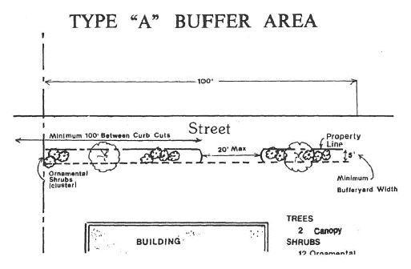

Type “B” Buffer Area.
Consists of a medium density screening intended to block visual contact between uses and to create spatial separation. The buffer area shall be a minimum width of 10 feet.

Per 100 lineal feet the screen shall consist of a combination of two (2) deciduous trees planted 40 to 60 feet on center and eight (8) evergreen plants 10 feet on center.

An example site plan is illustrated by the diagram on the following page. Refer to Figure 8-3.

Figure 8-3, Type “B” Buffer Areas
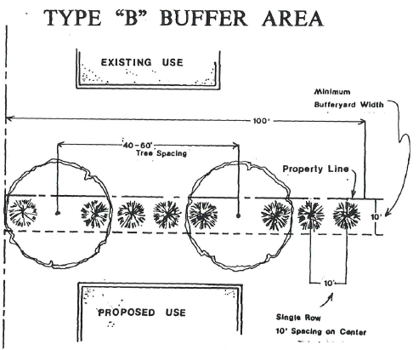

Figure 8-4, Type “C” Buffer Areas
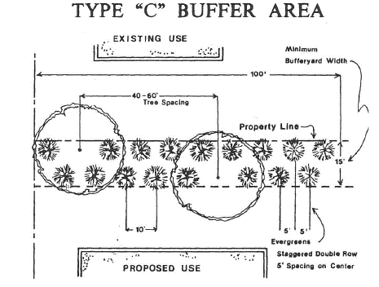

Type “C” Buffer Area.
Type “C” Buffer Area is a high density screen intended to exclude all visual contact between uses and to create spatial separation. The buffer area shall be a minimum width of 15 feet. Per 100 lineal feet the screen shall consist of a combination of two (2) deciduous trees planted 40 to 60 feet on center and 17 evergreen plants or understory trees planted in a double-staggered row 10 feet on center. Refer to Figure 8-4.

8.3.6 Buffer Area Specifications
- Minimum Installation Size.

At installation or planting, all evergreen (understory) trees used to fulfill buffer area requirements shall be not less than six (6) feet in height, and all deciduous (canopy) trees shall be not less than eight (8) feet in height, except for ornamental shrubs for Type A Buffer Areas. At installation or planting, all ornamental shrubs shall be not less than one (1) foot in height, and all standard shrubs shall be not less than two (2) feet in height.

- Minimum Mature Size.

At maturity, evergreen plant material used for screening shall form a continuous opaque screen averaging 10 feet in height, and deciduous plant material used for screening shall average 25 feet in height.

- Staggered Planting.

Where required, evergreen and deciduous plant material shall be planted in at least two (2) rows and in an alternating fashion to form a continuous opaque screen of plant material.
8.3.7 Substitutions
The following substitutions shall satisfy the requirements of this Section:
1. Existing Plant Materials.
Existing trees of four (4) inches or more in diameter, within the required buffer area may be included in the computation of the required buffer area planting, with approval of the Zoning Administrator.
2. Fence or Wall.
Where, owing to existing land use, lot sizes, or configurations, topography, or circumstances peculiar to a given piece of property, the buffer area requirements of this Section cannot reasonably be met, the developer(s) may request and the Zoning Administrator may approve the substitution of appropriate screening, in the way of a fence or wall structure along the property line of the proposed use in accord with the provisions of this Section.
The Zoning Administrator may approve substitution of an opaque fence or wall at least six (6) feet in height, but not exceeding ten (10) feet in height, for a Type B or Type C buffer. Fences and walls shall be neat in appearance and have a finished surface facing adjacent property.
All fences and walls used as part of the buffer area requirements must have a finished side that is facing adjoining property. The interior side of the fence or wall may be finished as owner deems appropriate.
8.3.8 Responsibility
It shall be the responsibility of the proposed new use to provide the buffer area where required by this Ordinance. Existing uses are not required to install such buffers.
8.3.9 Required Maintenance
The maintenance of required buffer areas shall be the responsibility of the property owner. All such areas shall be properly maintained so as to ensure continued buffering. All planted areas shall be provided with an irrigation system or a readily available water supply to ensure continuous healthy growth and development. Dead trees shall be removed and replaced; debris and litter shall be cleaned; and berms, fences, and walls shall be maintained at all times. Failure to do so is a violation of this Ordinance, and may be remedied in the manner prescribed for other violations.
8.3.10 Use of Buffer Areas
A buffer area may be used for passive recreation; however no plant material may be removed. All other uses are prohibited, including off-street parking.
Section 8.4 Screening
8.4.1 Definition
Screening is a type of buffer that is designed to block or obscure a particular element or use from view.
8.4.2 Purpose
The purpose of screening is to minimize if not eliminate entirely the visual impact of open storage areas and refuse disposal facilities.
8.4.3 Where Required
Screening specified by this section shall be required of all open storage areas, existing or proposed, visible from any public street, including open storage areas for building materials, appliances, trash containers of four (4) or more cubic yards, salvage materials and similar unenclosed uses. All existing open storage areas shall be made to comply with the provisions of this section within six (6) months of the effective date of this Ordinance. Failure to comply within said time period shall constitute a violation of this Ordinance, subject to the penalties contained in Article XI.
8.4.4 Type Screening Required
Screening shall be accomplished by an opaque divide not less than six (6) feet high. Screening may be accomplished by the use of sight obscuring plant materials (generally evergreens), earth berms, walls, fences, proper siting of disruptive elements, building placement or other design techniques approved by the Zoning Administrator.
Section 8.5 Landscaping
8.5.1 Definition
Landscaping is a type of open space permanently devoted and maintained for the growing of shrubbery, grass, other plants and decorative features to the land.
8.5.2 Purpose
The purpose of landscaping is to improve the appearance of vehicular use areas and development abutting public right-of-way; to protect, preserve, and promote the aesthetic appeal, scenic beauty, character and value of land; to promote public health and safety through the reduction of noise pollution, storm water run-off, air pollution, visual pollution and artificial light glare.
8.5.3 Where Required
No proposed commercial, institutional, industrial or other non-residential use shall hereafter be established and subsequently used unless landscaping is provided in accord with the provisions of this Section. No existing building, structure or vehicular use area shall be expanded or enlarged by 50 percent or more unless the minimum landscaping required by the provisions of this section is provided throughout the building site. Enlargements involving less than 50 percent shall meet the requirements of this enlargements only. Landscaping is not required for existing uses, nor is it required in the C-1 District.
8.5.4 Landscaping Plan
A landscaping plan shall be submitted as part of the application for a building permit. The plan shall:
- Designate areas to be reserved for landscaping. The specific design of landscaping shall be sensitive to the physical and design characteristics of the site.

- Indicate the location and dimensions of landscaped areas, plant materials, decorative features, etc.

- Identify all existing trees 12” diameter in required setback areas.

8.5.5 Landscaping Requirements
Required landscaping shall be provided as follows:
- Along the outer perimeter of a lot or parcel, where required by the buffer area provisions of this Article to buffer and separate incompatible land uses. Refer to Figure 8-3. The amount specified shall be as prescribed by Section 8-1.
- Within the interior, peninsula or island type landscaped areas shall be provided for any open vehicular use area containing 20 or more parking spaces. Landscaped areas shall be not less than 5’X6’ and located in such a manner as to divide and break up the expanse of paving and at strategic points to guide travel flow and directions. Elsewhere, landscaped areas shall be designed to soften and complement the building site.
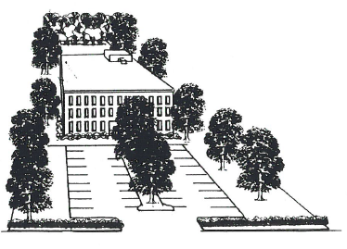
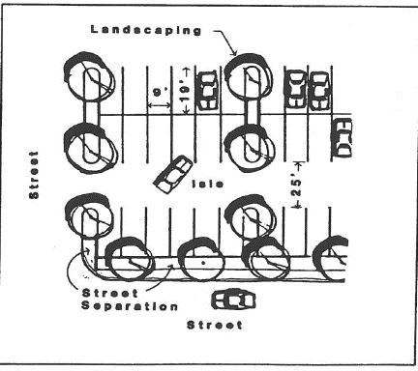
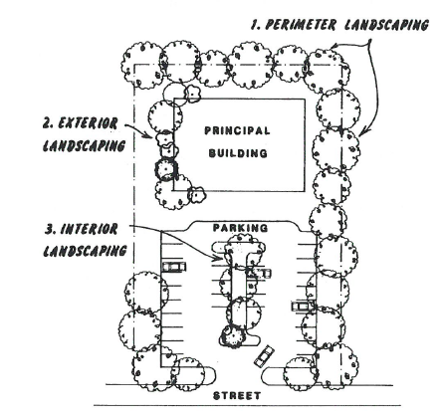
Figure 8-5, Typical Landscaping Site Plan

At a minimum, interior lot landscaping shall be provided in the following amounts:
Table 8-2, Minimum Percent of Land Use for Interior Landscaping

LAND USE | % of Lot
Institutional | 15%
Industrial/ Wholesale/ Storage | 10%
Office/Professional | 10%
Commercial/Retail/Service | 5%
Buffer Area landscaping may provide up to 50% of the above requirement. Landscaping along exterior building walls and structures is suggested to separate with greenery the building from the vehicular surface area.

8.5.6 Landscape Areas
All landscaped areas in or adjacent to parking areas shall be protected from vehicular damage by a raised concrete curb or an equivalent barrier of six (6) inches in height. The barrier need not be continuous. Refer to Table 8-2.
Landscaped areas must be at least 25 square feet in size and a minimum of three (3) feet wide to qualify.
Landscaped areas adjacent to parking spaces shall be landscaped so that no plant material greater than 12 inches in height is located within two (2) feet of the curb or other protective barrier.
8.5.7 Required Maintenance
The maintenance of required landscaped areas shall be the responsibility of the property owner. All such areas shall be properly maintained so as to assure their survival and aesthetic value, and shall be provided with an irrigation system or a readily available water supply. Failure to monitor such areas is a violation of this Ordinance, and may be remedied in the manner prescribed for other violations.
Section 8.6 Open Space
8.6.1 Definition
Common open space is land and/or water bodies used for recreation, amenity or buffer; it shall be freely accessible to all residents and property owners of a development, where required by this Ordinance.
8.6.2 Purpose
The purpose of this Section is to ensure adequate open space for high density residential development; to integrate recreation, landscaping, greenery and/or natural areas into such projects; to promote the health and safety of residents of such projects; and to compensate for the loss of open space inherent in single-family residential subdivisions.
8.6.3 Open Space Landscaping Requirements
The following open space landscaping requirements shall apply to land uses in all zoning districts:

Table 8-3, Open Space Landscaping Requirements

LAND USE | OPEN SPACE REQUIRED | LANDSCAPING
Single-family and two-family residential, except clustered | District yard requirements. | None required.
Clustered residential developments | 15% of land area. | Grass, shrubs and trees selected by owner.
Townhouse projects | 15% of land area. | Grass, shrubs and trees selected by owner.
Manufactured home park | 2,500 square feet for each acre or major fraction of an acre in the park. | Greenbelt along all interior lot lines.
Multi-family residential, commercial and industrial, except surface parking lots | 20% of land area.  Required buffer areas, woodlands and wetlands may be used to satisfy requirements. | Grass, shrubs and trees selected by owner.
Surface parking lots | 100 square feet of planted area for each 20 parking spaces.  Required buffer areas may be used to satisfy requirements. | One evergreen or deciduous tree for each 20 parking spaces.  Grass and shrubs selected by owner.

8.6.4 Common Open Space Plan
Proposed uses/projects set forth in 8.6.3 shall submit an open space or landscaping plan as part of the application for a building permit. The plan shall:
- Designate areas to be reserved for open space. The specific design of open space shall be sensitive to the physical and design characteristics of the site.

- Designate the type of open space which will be provided, and indicate the location of plant materials, decorative features, recreational facilities, etc.

- Specify the manner in which common open space shall be perpetuated, maintained and administered.
8.6.5 Types of Common Open Space and Required Maintenance.
The types of common open space which may be provided to satisfy the requirements of this Ordinance together with the maintenance required for each are as follows:
- Natural areas of undisturbed vegetation or areas replanted with vegetation after construction. Woodlands and wetlands are specific types of natural areas. Maintenance is limited to removal of litter, dead trees, plant materials, and brush. Natural water courses are to be maintained as free-flowing and devoid of debris. Stream channels shall be maintained so as not to alter floodplain levels.
- Recreational areas are designed for specific active recreational uses such as tot lots, tennis courts, swimming pools, ballfields, and similar uses. Recreational areas shall be accessible to all residents of the development. Maintenance is limited to ensuring that there exist no hazards, nuisances, or unhealthy conditions.
- Greenways are linear green belts linking residential areas with other open space areas. These greenways may contain bicycle paths, footpaths, and bridle paths. Connecting greenways between residences and recreational areas are encouraged. Maintenance is limited to a minimum of removal and avoidance of hazards, nuisances, or unhealthy conditions.
- Landscaped areas, lawns and required buffer areas, including creative landscaped areas with gravel and tile, so long as the tile does not occupy more than two (2) percent of the required open space. Lawns, with or without trees and shrubs shall be watered regularly to ensure survival, and mowed regularly to ensure neatness. Landscaped areas shall be trimmed, cleaned and weeded regularly.
8.6.6 Preservation of Open Space
Land designated as common open space may not be separately sold, subdivided or developed. Open space areas shall be maintained so that their use and enjoyment as open space are not diminished or destroyed. Open space areas may be owned, preserved and maintained as required by this Section by any of the following mechanisms or combinations thereof:
- Dedication of and acceptance by the Town.
- Common ownership of the open space by a home-owner’s association which assumes full responsibility for its maintenance.
- Deed restricted, private ownership which shall prevent development and/or subsequent subdivision of the open space land and provide the maintenance.
In the event that any private owner of open space fails to maintain same, the Town may in accordance with the Open Space Plan and following reasonable notice, demand that deficiency of maintenance be corrected, and enter the open space to maintain same. The cost of such maintenance shall be charged to those persons having the primary responsibility for maintenance of the open space.
Section 8.7 Tree Protection
8.7.1 Purpose
The purpose of this Section is to prevent the clear cutting of building sites, a practice which destroys the balance of nature, leads to sedimentation and erosion, contributes to air and water pollution, and unnecessarily robs the community of valuable natural resources.
8.7.2 Existing Trees of Significance
Because any healthy tree greater than twelve inches in diameter is a valuable natural resource, by virtue of its age and size and its contribution to the environment, all said trees meeting this measurement shall be referred to as “significant trees” and protected to the extent practical and feasible.
All existing significant trees located in all required yards, open space and buffer areas shall be flagged and shown on the required plat or site plan for a building permit or grading permit.
No more than 25 percent of said trees shall be felled and removed, except by order of the Board of Zoning Appeals owing to unique circumstances surrounding the development of the property.
Where, due to unusual topographic conditions or circumstances peculiar to a given site, more than 25 percent of the trees to be preserved must be felled, replacement trees measuring not less than two (2) inches in diameter shall be planted in like number. To the extent possible, said trees shall be integrated into the required landscaping.
8.7.3 Removal of Existing Trees of Significance
Removal of existing significant trees shall be prohibited prior to securing a grading and/or building permit. However, in the event that a tree poses a severe or imminent threat to public safety or property, the Zoning Administrator or his designee may waive the requirements of this Section. Written findings must later be issued, outlining the threat which initiated the removal. The Zoning Administrator or his designee may require replacement of any trees which are removed where it is determined that the threat resulted from negligence.
8.7.4 Significant Trees Removed Without Permits
Where significant trees have been removed or where removal is necessitated at any time due to acts of negligence, or where sites were cleared of significant trees in violation of this Section, replacement trees shall be planted in accordance with a replacement schedule approved by the Board of Zoning Appeals.
The Zoning Administrator or his designee shall recommend the number, species, diameter, and location of replacement trees, according to the following criteria:
- Combined diameter of replacement trees is equal to or greater than three (3) times the diameter of the tree removed or;
- Individual replacement trees are of the largest transplantable diameter available.
Where significant tree removal is necessitated by emergencies or death and disease of trees due to natural causes, as determined by the Zoning Administrator or his designee, replacement will not be required.
8.7.5 Development Precautions
After the necessary permit approvals have been granted, and before any site work has begun, the developer shall cause protected trees to be marked with surveyor’s flagging. During development, a minimum protective zone, marked by barriers, shall be established at the “drip line” and maintained around all trees to be retained as required by this Section. There shall be no construction, paving, grading, operation of equipment or vehicles, or storage of materials within this protected zone. Refer to Figure 8-6.
Figure 8-6, Minimum Tree Protective Zone
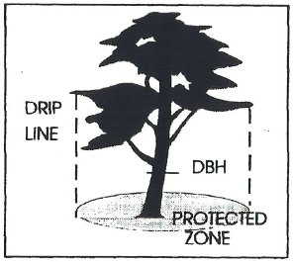

8.7.6 Cutting, etc. of Significant Trees Prohibited
No person shall cut down, remove, relocate, damage, destroy, or in any manner abuse any significant tree on any lot or tract or public right-of-way in the Town unless authorized by the terms of this Section or unless approved by the Zoning Administrator.
Section 8.8 Off-Street Parking
Off-street parking spaces required by district regulations shall be located on the same lot as the principal use, or on a lot within 400 feet of the main entrance to the principal use which under the same ownership as the principal use or has been legally restricted for parking in connection with the principal use, and shall have required buffer and landscaped areas.

Required off-street parking for a commercial or industrial use may extend up to 120 feet into a residential zoning district provided: (1) the parking area adjoins the property on which the principal commercial or industrial use is located; (2) the parking area access is to the same street as the principal use; and (3) the parking area has a Type B buffer area along residential lot lines and required landscaping.

Combined parking areas serving two (2) or more principal uses shall contain spaces equal in number to the total of spaces required for all principal uses served.

Section 8.9 Parking Space Requirements
Required off-street parking must be provided on the same lot or parcel as the principal use for which it is required. Refer to Table 8-4. Where off-street parking for ten (10) or more vehicles is required, the off-street parking spaces shall meet the following design and development standards:

Table 8-4, Parking Space Requirements

Parking Detail | Requirement
Parking space dimensions: | Angle parking: Nine (9) feet by 19 feet; provided, 10% may be 8.5 feet by 18 feet;  Parallel parking: Nine (9) feet by 24 feet;  Handicapped: 12 feet by 20 feet, or eight (8) feet by 20 feet, with eight (8) foot isle.
Minimum isle widths: | 90 degree parking - 25 feet; 60 degree parking - 18 feet;  45 degree parking - 13 feet; parallel parking - 10 feet.  Minor street rights-of-way may be considered as isles for adjacent off-street parking.
Paving and marking requirements: | A parking area, including driveways, containing ten (10) or more parking spaces shall be surfaced with an all-weather impervious material, and spaces shall be marked with painted lines. Pavement materials may consist of asphalt, crushed stone, gravel or other material approved by the Zoning Administrator. Parking lot construction shall be designed to minimize off-site storm water run-off.
Lighting requirements: | A parking area open for night use shall have a minimum of one 9,000 lumen overhead light for each 25 parking spaces, or major portion thereof.

Table 8-4, Parking Space Requirements (Cont.)
Parking Detail | Requirement
Drainage: | Parking lots shall be designed so as not to drain into or across public sidewalks or onto adjacent property, except into a natural watercourse or a drainage easement. In developed areas, exemptions from this requirement may be made by the Zoning Administrator as this condition may not be possible to meet. An alternate provision for adequate drainage must be made.
Parking spaces for handicapped persons: | One (1) parking space for handicapped persons shall be provided for each 25 parking spaces, or fraction thereof, except for dwellings of less than three (3) units, meeting federal and State requirements, with access to ramps, walkways, and entrances without moving behind parked vehicles.
Separation from Walkways and Streets: | Off-street parking spaces shall be separated from walkways, sidewalks, streets or alleys, and required yards and buffer areas by a wall, fence, curbing, or other approved protective barrier.

Section 8.10 Off-Street Loading and Unloading Spaces
All uses shall provide off-street loading and unloading space so that no vehicle being loaded or unloaded in connection with normal operations shall stand in or project into a public street, walkway, alley, or private street. Refer to Table 8-5.

Each lot used for commercial or industrial purposes, or multi-family residences with more than ten (10) units, shall provide off-street space for loading and unloading as follows:

Table 8-5, Off Street Loading and Unloading

Detail | Requirement
Access | Each space shall have access from an alley or public street.
Dimensions | Each space shall be a minimum of 12 feet by 40 feet, clear of obstructions.
Spaces required: | Use | Gross Floor Area  [square feet] | No. of Spaces
 | Retail Business | For each 5,000 | 1
 | Wholesale/Industrial  Governmental Institutional  Educational/Medical Assembly* | 0 - 25,000  25,000 - 40,000  40,000 - 100,000  100,000 - 160,000  160,000 - 240,000  *each additional 100,000 | 1  2  3  4  5  1
 | Multi-family residence with 10 or more units |  | 1

Section 8.11 Approval of Parking and Off-Street Loading Plans
Designs and plans for areas to be used for off-street parking and off-street loading and unloading shall be subject to approval by the Zoning Administrator, who may withhold a permit or take other action if the layout of either would create avoidable safety or traffic congestion issues, pending acceptable modification of the layout, or appeal to the Board of Zoning Appeals.
Section 8.12 Parking of Unlicensed Vehicles
In a residential district, any vehicle or trailer subject to State licensing which does not display a current license plate shall be parked or stored within an enclosed building or parked behind the building set-back line and covered with a waterproof tarp or located under a shed roof.

Section 8.13 Parking of Recreational, Oversize and Emergency Vehicles
A. Recreational Vehicles
A recreational vehicle (including motor homes, travel or camper trailers, pickup campers, boats, and boat trailers) may be parked or stored on any lot in a residential zoning district in accordance with the following standards:
- On an interior lot, the recreational vehicle is parked in an enclosed building, or in the rear yard, or in the side yard not projecting beyond the front of the roof line of the principal dwelling on the lot.
- On a corner lot, the recreational vehicle is parked in an enclosed building, or in the rear yard, or in the side yard not projecting beyond the front of the roof line of the principal dwelling on the lot; if parked in the rear or side yard, the recreational vehicle must be completely screened by evergreen vegetation from view from all streets that run along the rear yard or side yard in which it is parked.
- The recreational vehicle is parked or stored entirely on the residential lot in a safe and orderly condition, and if parked or stored on a driveway, it shall not be a hazard to persons or vehicles entering or exiting the driveway, persons passing on the sidewalk, or persons in vehicles passing on any adjoining street.
- The combined total number of recreational vehicles and oversized vehicles permitted so parked or stored on any residential lot shall be limited to three (3), not including those kept in a garage or other enclosed building.
- A recreational vehicle may be parked anywhere on a residential lot for a period not to exceed 24 hours for the purposes of loading and unloading.
- A recreational vehicle shall not be used for the purposes of permanent human habitation while parked or stored on any residential lot. Temporary storage or parking of a recreational vehicle for housing of temporary guests shall be permitted for a period not to exceed two (2) consecutive weeks during any one calendar year.
B. Oversize Vehicles Other Than Recreational Vehicles
- Any vehicle or combination of vehicles exceeding 26,000 pounds Gross Vehicle Weight Rating (GVWR), or any vehicle designed to transport 16 or more passengers including the driver, or any vehicle placarded for hazardous materials shall be prohibited in a residential zone except to allow deliveries or provide services to residents.
- Any vehicle which has an overall vehicle length exceeding 22.5 feet in length or eight (8) feet in height, excluding trailer hitches, winches, handicapped accessories, roof racks, etc. must be located and screened in the same manner as a recreational vehicle as set forth in Section 8.13. The total combined number of those oversize vehicles and recreational vehicles permitted, parked or stored on any residential lot shall be limited to three (3).
- No such vehicle may be parked on a lot in a residential zone unless the lot is occupied by a single-family dwelling and the vehicle is operated by the occupant of the dwelling.
- This section shall not apply to any vehicle kept in a garage or other enclosed building.
C. Emergency Vehicles
One emergency vehicle may be located on a lot occupied by a single-family dwelling as long as the vehicle complies with the standards for recreational vehicles in Section 8.13, and the vehicle does not use its siren or flashing lights while on the lot. Emergency vehicles may be located in a multi-family or attached single-family residential property in an area screened from view.
For the purposes of this section, an emergency vehicle is an ambulance or a tow truck displaying a decal in a prominent location verifying that it is licensed by the State of South Carolina to provide emergency road service.

